1. **Your well documented (with your name and date) YACC code**

/*

Lab5, LEX and YACC routines using BNF to parse input

Christian McGovern

Feb 28 2018

*/

%{ /* begin specs */

#include <stdio.h>

#include <ctype.h>

#include "lex.yy.c"

int base, debugsw;

void yyerror (s) /* Called by yyparse on error */

char *s;

{

printf ("%s on Line number: %d\n", s, lineno);

}

%}//end of c definitions

/* defines the start symbol, what values come back from LEX and how the operators are associated */

%start P

%union{

int value;

char * string;

}

%token INT VOID IF ELSE WHILE RETURN READ WRITE LE LT GT GE EQ NE

%token <string> ID

%token <value> NUM

%left '|'

%left '&'

%left '+' '-'

%left '*' '/' '%'

%left UMINUS

%% /* end specs, begin rules */

P : DL /*program -Decleration-list*/

;

DL : DEC

| DEC DL

;

DEC : VARDEC | FUNDEC

;

VARDEC : typespec ID ';'

| typespec ID '[' NUM ']' ';'

;

typespec : INT

| VOID

;

FUNDEC : typespec ID '(' params ')' compoundstmt

;

params : VOID

| paramlist

;

paramlist : param

| param ',' paramlist

;

param : typespec ID

| typespec ID '[' ']'

;

compoundstmt : '{' localdeclarations statementlist '}'

;

localdeclarations : /* empty */

| VARDEC localdeclarations

;

statementlist : /*empty */

| statement statementlist

;

statement : expressionstmt

| compoundstmt

| selectionstmt

| iterationstmt

| assignmentstmt

| returnstmt

| readstmt

| writestmt

;

expressionstmt : ';'

| expression ';'

;

assignmentstmt : var '=' expression ';'

;

selectionstmt : IF '(' expression ')' statement

| IF '(' expression ')' statement ELSE statement

;

iterationstmt : WHILE '(' expression ')' statement

;

returnstmt : RETURN ';'

| RETURN expression ';'

;

readstmt : READ var ';'

;

writestmt : WRITE expression ';'

;

expression : simpleexpression

;

var : ID

| ID '[' expression ']'

;

simpleexpression : additiveexpression

| additiveexpression relop simpleexpression

;

relop : LE | LT | GT | GE | EQ | NE

;

additiveexpression : term

| term addop additiveexpression

;

addop : '+' | '-'

;

term : factor

| factor multop term

;

multop : '*' | '/'

;

factor : '(' expression ')' | NUM | var | call

;

call : ID '(' args ')'

;

args : /*empty*/ | arglist

;

arglist : expression

| expression ',' arglist

;

%% /* end rules */

main()

{ yyparse();

}

1. **Your well documented LEX code**

/*

* Lex Program

* Christian McGovern

* Lab 5, 2/28

*/

%{

int mydebug=1;

int lineno=1;

#include "y.tab.h"

%}

letter [a-zA-Z][a-zA-Z]*

num [0-9][0-9]*

id {letter}({letter}|{num})*

/*Begin Rules*/

%%

int {if (mydebug) fprintf(stderr,"int found\n");

return(INT);}

void {if (mydebug) fprintf(stderr,"void found\n");

return(VOID);}

if {if (mydebug) fprintf(stderr,"if found\n");

return(IF);}

else {if (mydebug) fprintf(stderr,"else found\n");

return(ELSE);}

while {if (mydebug) fprintf(stderr,"while found\n");

return(WHILE);}

return {if (mydebug) fprintf(stderr,"return found\n");

return(RETURN);}

read {if (mydebug) fprintf(stderr,"read found\n");

return(READ);}

write {if (mydebug) fprintf(stderr,"write found\n");

return(WRITE);}

[<][\=] {if (mydebug) fprintf(stderr,"LE found\n");

return(LE);}

[>][\=] {if (mydebug) fprintf(stderr,"GE found\n");

return(GE);}

[\=][\=] {if (mydebug) fprintf(stderr,"EQ found\n");

return(EQ);}

[\!][\=] {if (mydebug) fprintf(stderr,"LE found\n");

return(NE);}

[<] {if (mydebug) fprintf(stderr,"LT found\n");

return(LT);}

[>] {if (mydebug) fprintf(stderr,"GT found\n");

return(GT);}

{id} {if (mydebug) fprintf(stderr,"id found\n");

yylval.string=strdup(yytext);return(ID);}

{num} {if (mydebug) fprintf(stderr,"num found\n");

yylval.value=atoi((const char *)yytext); return(NUM);}

[ \t] {if (mydebug) fprintf(stderr,"Whitespace found\n");}

[;] { if (mydebug) fprintf(stderr, "return a semicolon %c\n", *yytext);

return (*yytext);}

[<>=()\-+*/%&\[\]|;{},] { if (mydebug) fprintf(stderr,"return a token %c\n",*yytext); //added () to set

return (*yytext);}

\n {lineno++;}

%%

/*End Rules*/

int yywrap(void)

{ return 1;}

1. **Your output when run with the code lab4badtest.c**

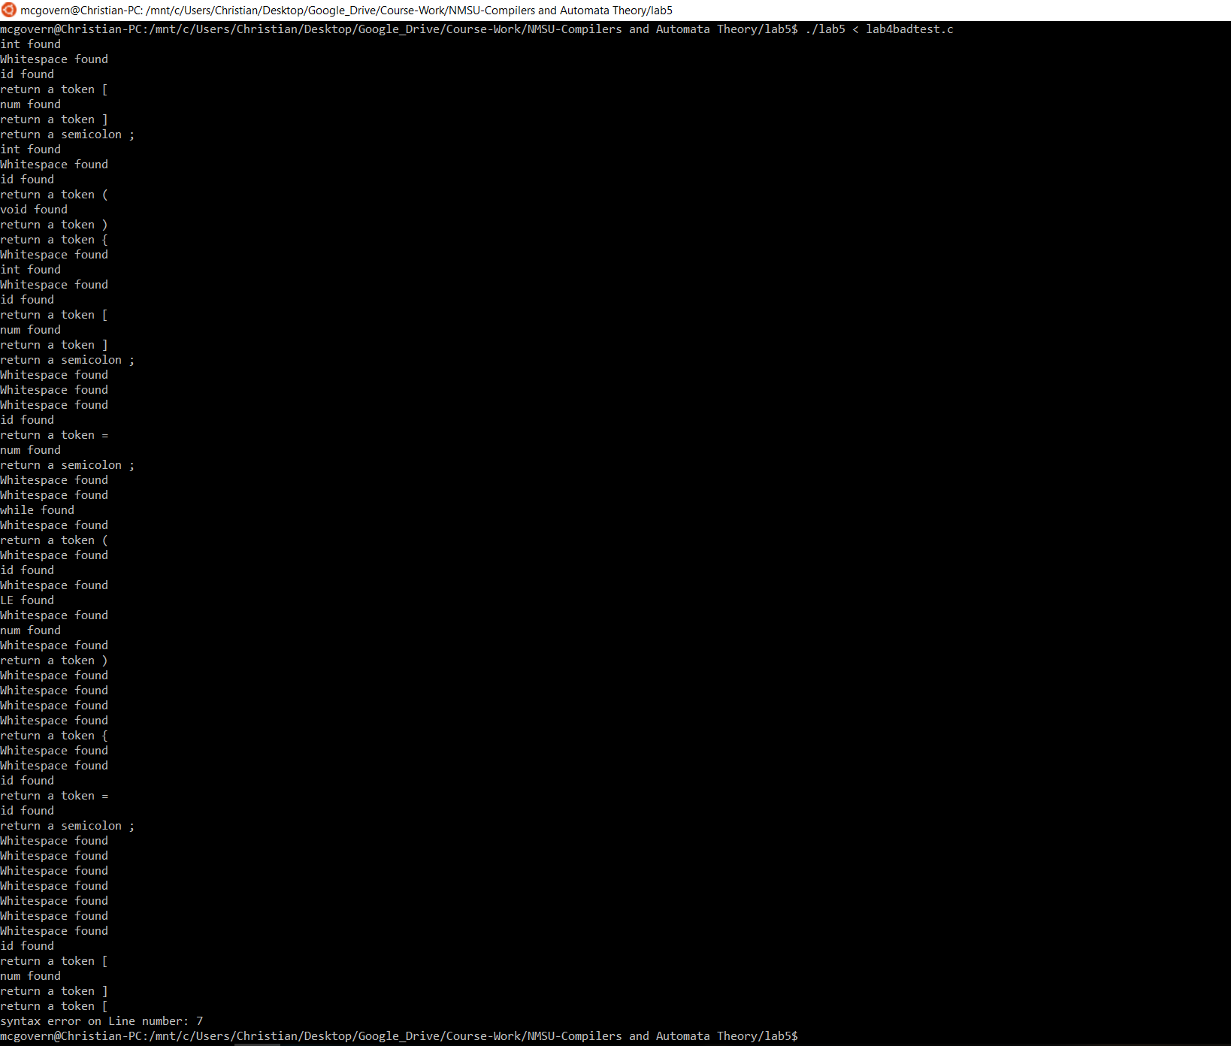

1. **Your output when run with the code lab4goodtest.c**

